# Week 6 Project Documentation (Joshua)

## Project Goal

Create a multiple choice quiz app

With questions and answers in a SQL database

* Have a database that has at least 2 tables, one for questions and one for answers, connected through a Primary key – Foreign key relationship
* Have at least 5 questions with 4 answers, where only one answer is correct

That can retrieve questions from a database.

* It is possible to print or manipulate the information from the sql database using c#
* The needed information can be put in an Array or List to be manipulated by code

That can be interacted with by a user

* Create a gui using wpf
* A method for starting the quiz
* Buttons for each of the possible answers
* A method for moving to the next question when the previous one is answered
* A method for keeping track of how many questions have been answered correctly
* That score does not change when the question is answered incorrectly
* That notifies the user when the quiz is over

That has tests to ensure that the code is executing commands as expected

* Use test cases to ensure that the score is correct
* Use test cases to ensure that the question number is correct
* Test that the question number corresponds to the correct question

## Sprint0 (Fri-Sun)

* Choose a project idea
* Write bullet points on the necessary functionality for the idea
* Bullet points for the necessary features for the idea
* Bullet points of potential tests for the idea

## Sprint 1(Mon)

* Create a product backlog
* Compile the information gathered in spring0 to present in 1-2-1
* Adjust project scope to the

## Sprint 2(Tue)

* Create the SQL database
* Populate the database and add necessary keys and constraints
* Setup the Database connection in visual studios

See appendix 1 for ERD

## Sprint 3(Wed)

* Create queries to ensure that database connection is functional
* Apply the questions to a list
* Improve query to include answers table
* Define MVP/Narrow scope
* Create method for accessing Questions in order in the list and attaching to question display
* Create method for accessing Answers in order in the list and attaching to buttons

## Sprint 4(Thur)

* Create method for increasing score with correct answer
* Create method for changing question
* Create method for changing the answers on the buttons
* Create a method for ensuring that correct answer isn’t always the same button

## Sprint 5(Fri)

* Create method for preventing changing answer if question answered
* Prevent answering same question multiple times issue
* Add unit tests
* Polish the documentation to improve clarity
* Create class diagrams and add to documentation

Trelloboard in Appendix 3

## Appendix1

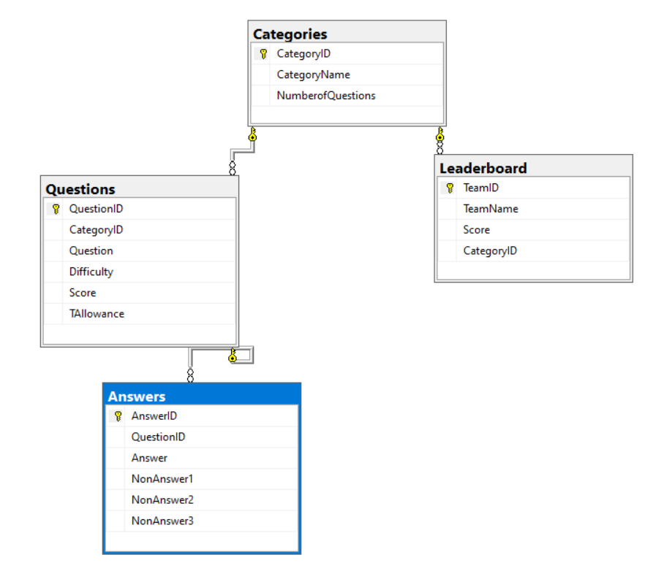

## Appendix 2

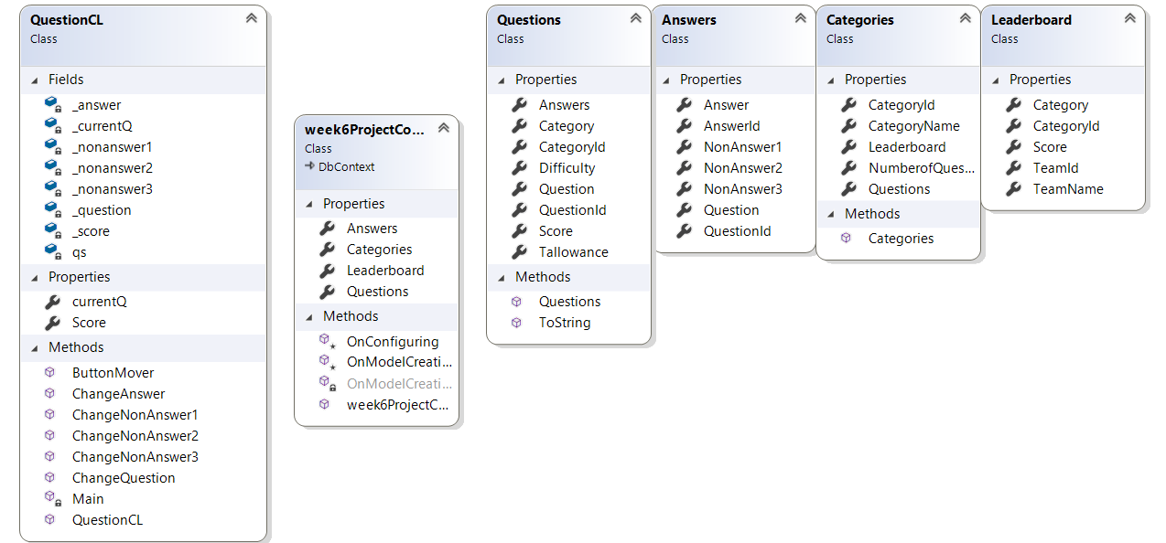

## Appendix 3

